**Solutions**

* **--With this data try to find out sum of balance**

select Sum(balance) from Bank_details

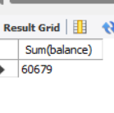

* **--Try to find out avarage of balance**

select Avg(balance) from Bank_details

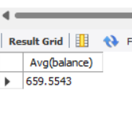

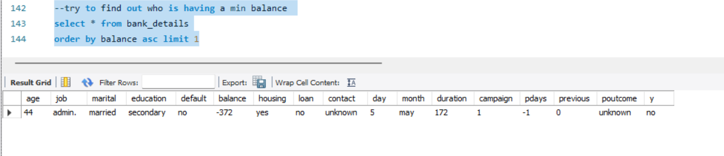

* **--try to find out who is having a mazxmim balance –**

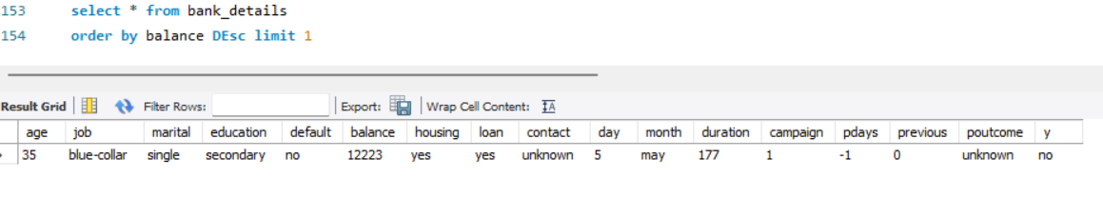

* **--try to prepare a list of all the person who is having loan**

select * from bank_details

where loan = 'yes'

select * from bank_details

where loan = 'yes'

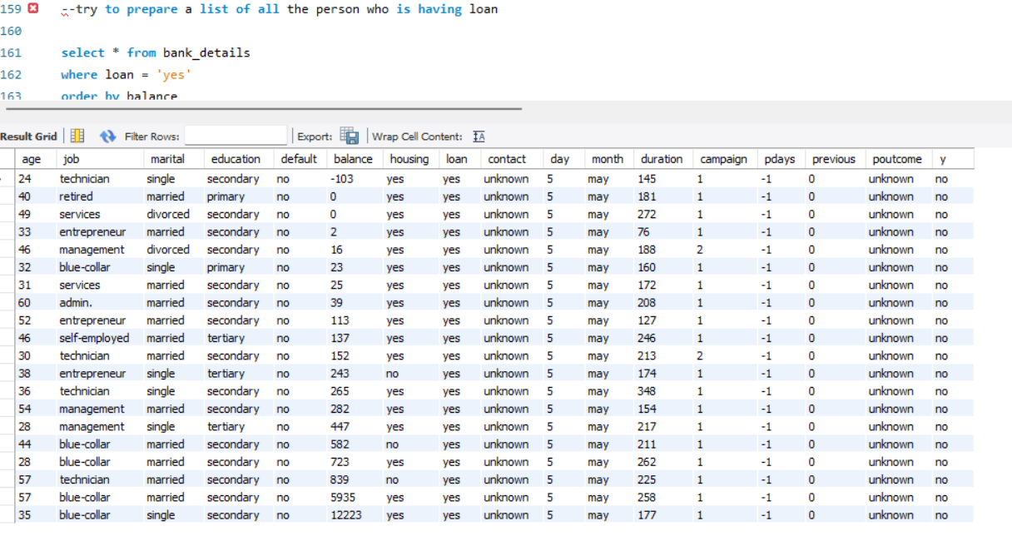 order by balance

* **--try to find out average balance for all the people whose job role is admin**

select avg(balance) from bank_details where job = 'admin.'

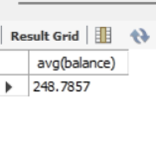

* **-- try to find out a record without job whose age is below 45**

select * from bank_details where job = 'unknown' and age <= 45



* **try to find out a record where education is primarty and person is jobless**

select * from bank_details where education = 'primary' and job = 'unknown'

no data

* **try to find of a record whose bank account is having a negative balance**

select * from bank_details where balance < 0

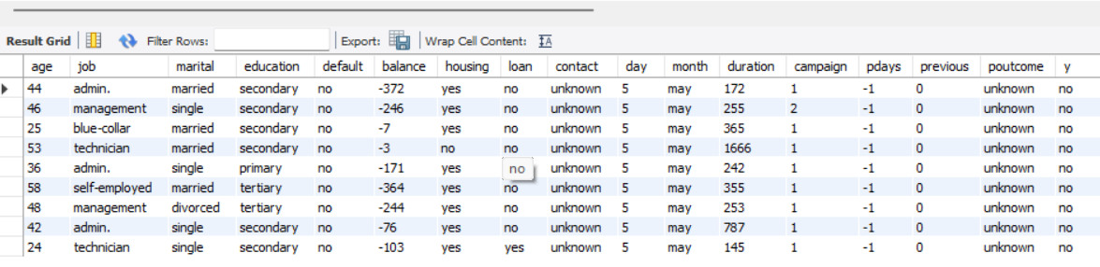

* **try to find out a record who is not having house at all along with there balance**

select balance , housing from bank_details where housing = 'no'

